Advanced Artificial Intelligence Assignment Report

The solution to a) was derived from the Artificial Neural Networks, workshop 2’s example of collecting probabilities from data.

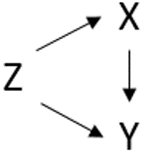

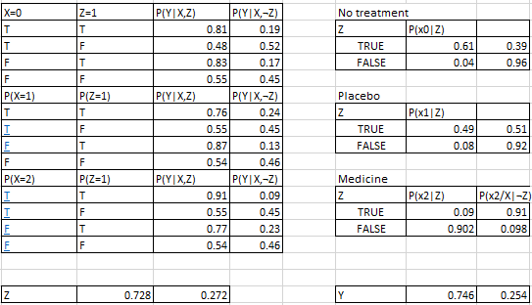

This is possible for the values of X as well which give us a table of 12 elements. There are 12 outputs because X can be 0, 1, or 2. Therefore we have to derive the probabilities for Y|(X, Z) for all possible values of x. Similarly the same has to be done for Z = 1, 0 as demonstrated in the tables.

Given the full joint probability P(y,x,z), of a set pf random variables, it is possible to answer the expansion of this gives us the following:

P(Y|X,Z), P(X,Z), P(Z)

To compute the intervention’s probability for part b, I wrote a function that takes in the values of x,y and z and then computes the intervention for all given values of X=0,1,2 and Z = 1,0. This returned the probability of Y being true and not being true for the cases

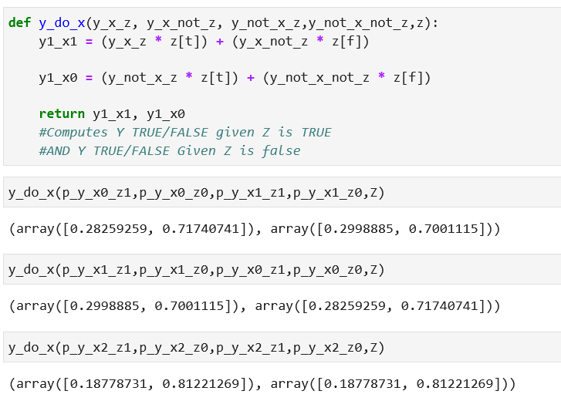

For part C I based my solution on the workshop 3 example based on the condition that:

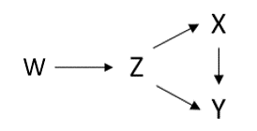



W in the full probability has no Parents and therefore the pre- and post-intervention are the same: 

Therefore:

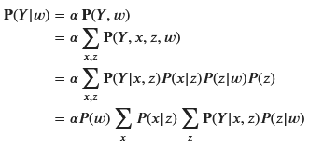

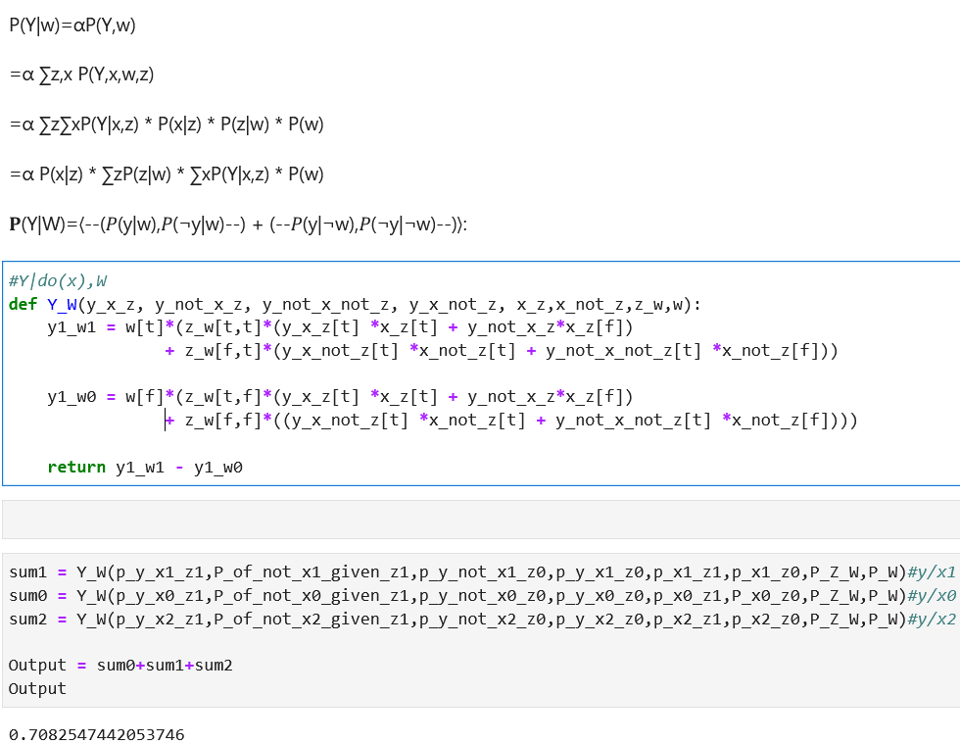

References

Nicola, B. (2021) Lecture 3 – Bayesian Networks, University of Lincoln,25th October. Available from: <https://blackboard.lincoln.ac.uk/webapps/blackboard/content/listContent.jsp?course_id=_166752_1&content_id=_5852525_1> [Accessed: 02/12/21]

Nicola, B. (2021) Lecture 6 – Casual Inference I, University of Lincoln, 15th November. Available from: <https://blackboard.lincoln.ac.uk/ultra/courses/_166752_1/cl/outline> [Accessed: 02/12/21]